Project Milestone 2: Exploring the Design Space

Groupmates: Anthony Thomas, Camryn Ottimo, Diego Ugaz, Anthony Panciocco

Project Type: Critical Report

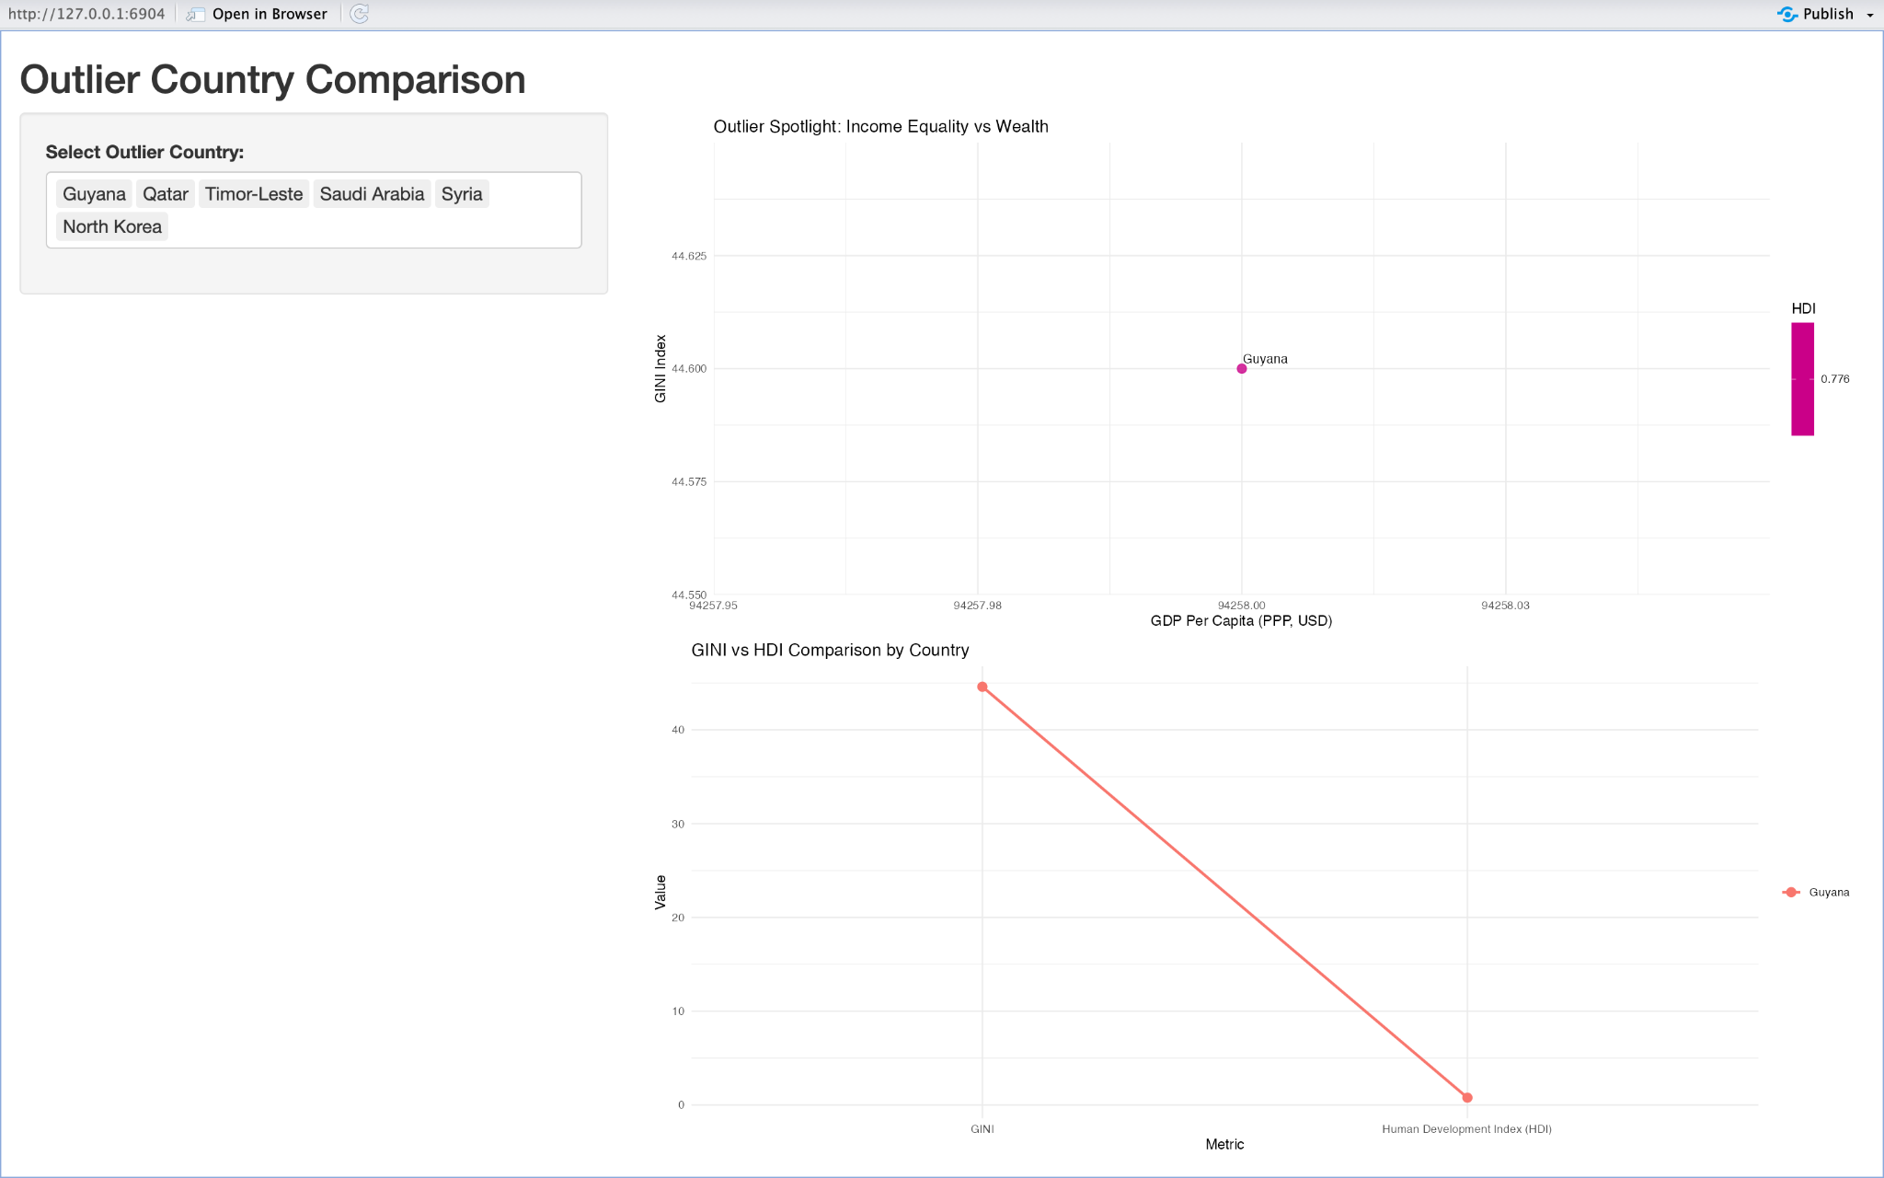

Visualization 1: Outlier Country Comparison (Interactive Shiny App)

How to interpret:

This dashboard lets you choose a country from a list of outliers (like Guyana or Qatar). When you select one, you see how its GINI (inequality) compares to its GDP per capita, and you also see its HDI score and how it compares to other outliers.

Why it matters:

It helps us spot countries that break the pattern, those that are rich but unequal, or poor but highly developed.

Example takeaway:

Selecting Guyana shows it has high GDP per capita and high inequality, with an HDI that’s lower than other rich countries.

Strength:

You can quickly see details for any outlier, which helps answer our question about which countries stand out.

Weakness:

You can only see one country at a time, so you can’t compare several at once.

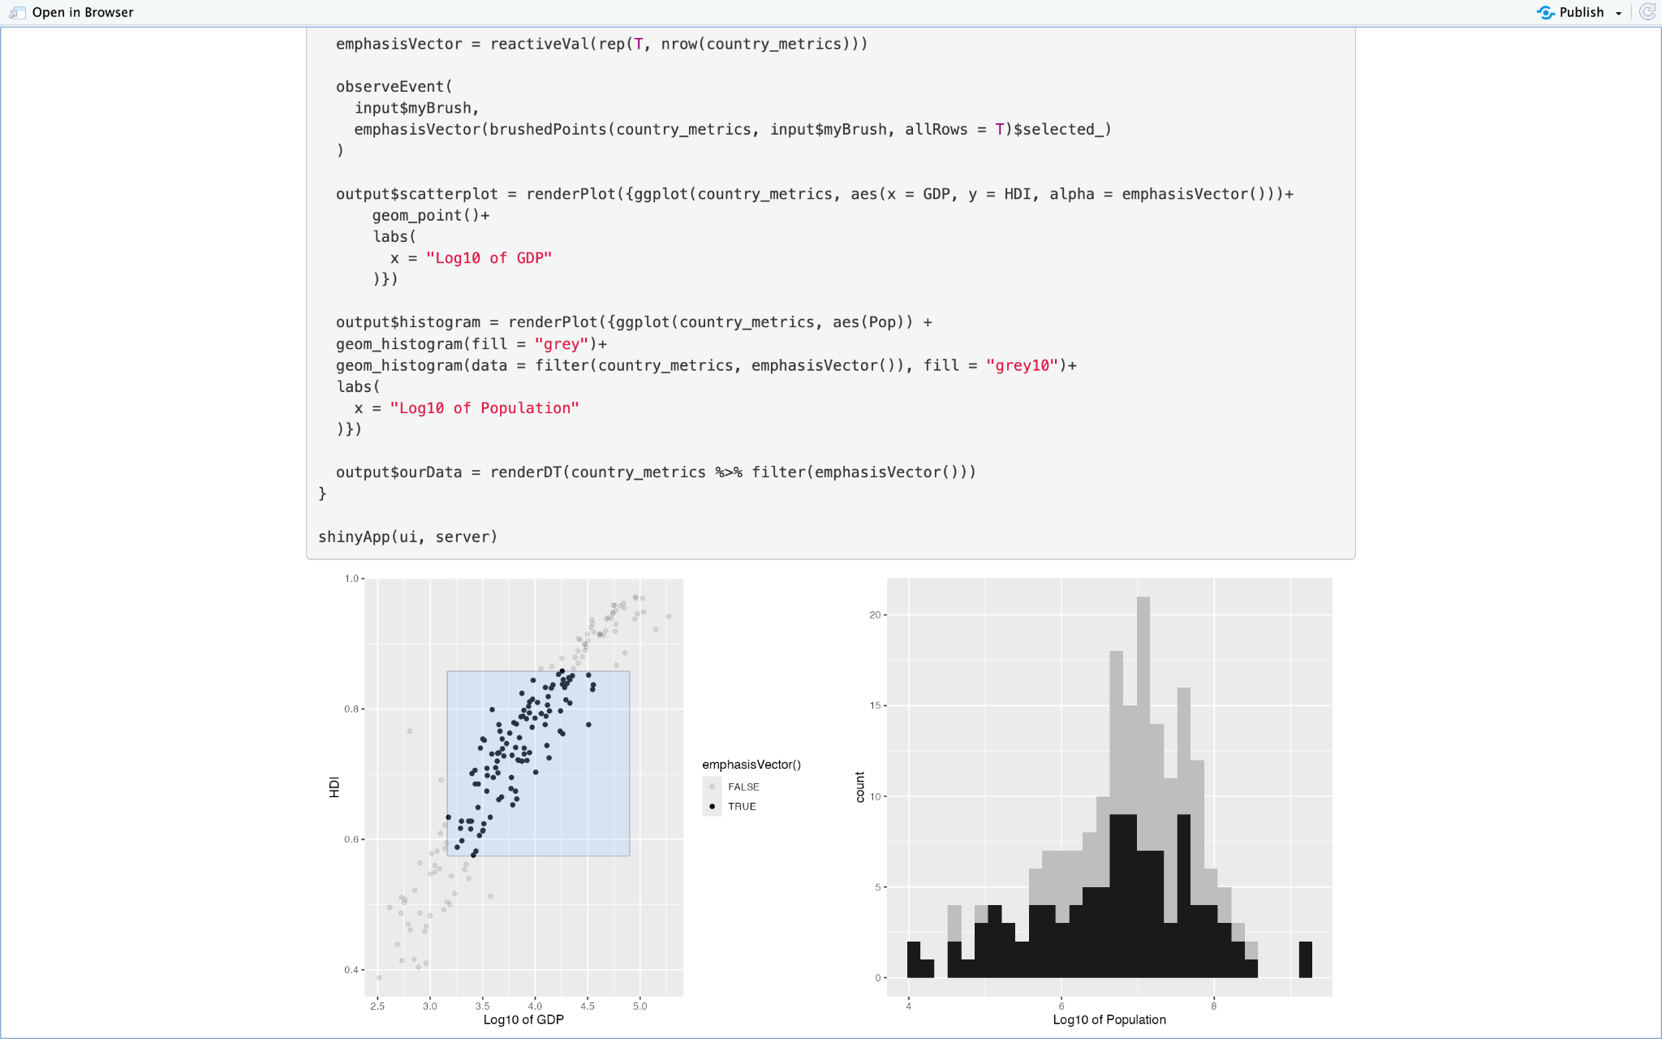

Visualization 2: Linked Scatterplot & Histogram with Brushing (Interactive)

How to interpret:

On the left, there’s a scatterplot of HDI (y-axis) vs. log10(GDP per capita) (x-axis). On the right, there’s a histogram of log10(Population). You can brush over groups of countries in the scatterplot, and the histogram updates to show how populations are distributed for those countries.

Why it matters:

This helps us explore if there’s a connection between population size, wealth, and development.

Example takeaway:

If you select high-HDI, high-GDP countries, you’ll notice they tend to have lower populations, showing that small countries often score higher in HDI.

Strength:

The interactivity helps explore patterns and subgroups very easily.

Weakness:

Brushing might be confusing for some users, and this visualization doesn’t include GINI (inequality).

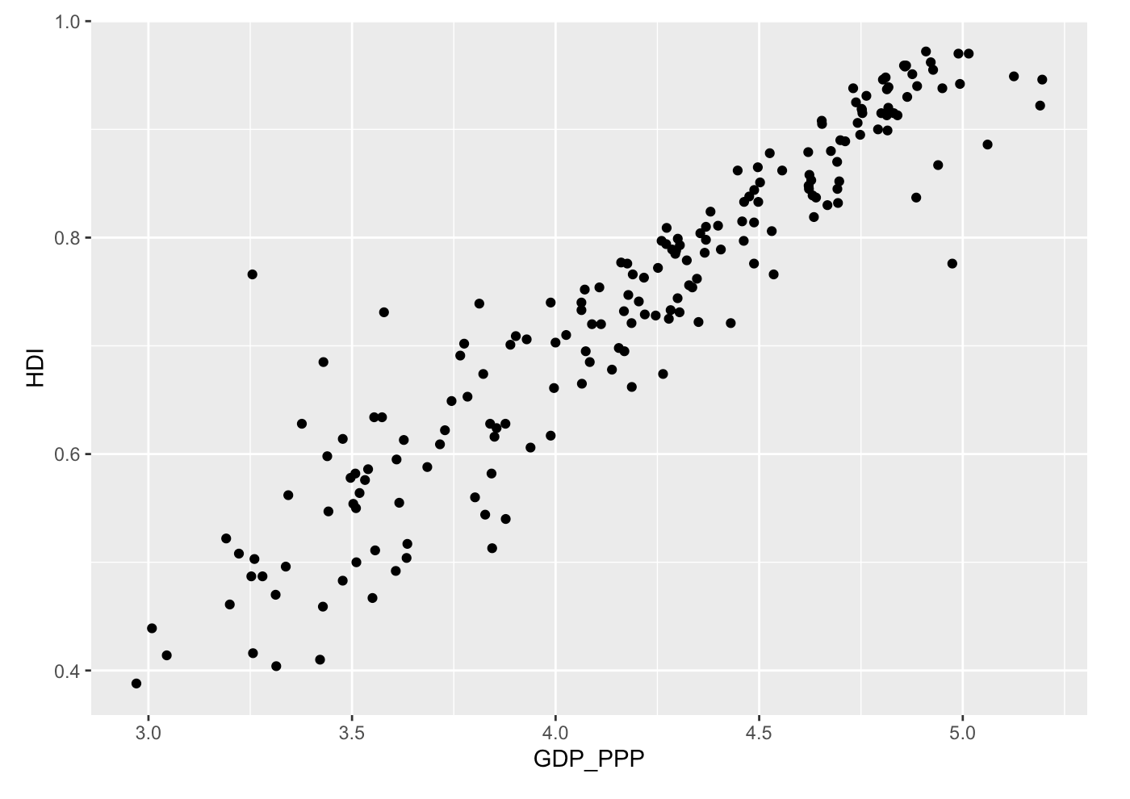

Visualization 3: HDI vs. Log10 GDP Scatterplot (Static)

How to interpret:

This scatterplot shows each country as a dot, plotting HDI on the y-axis and log10(GDP per capita) on the x-axis. The upward trend shows that more money usually means higher development.

Why it matters:

This directly addresses our main question: Does being richer mean a better quality of life?

Example takeaway:

Some countries have higher HDI than their income would suggest, while some are lower than expected. These outliers are important for our analysis.

Strength:

Simple, clean, and easy to spot big trends and outliers.

Weakness:

Not interactive, so you can’t see which dot is which country unless you add more details.

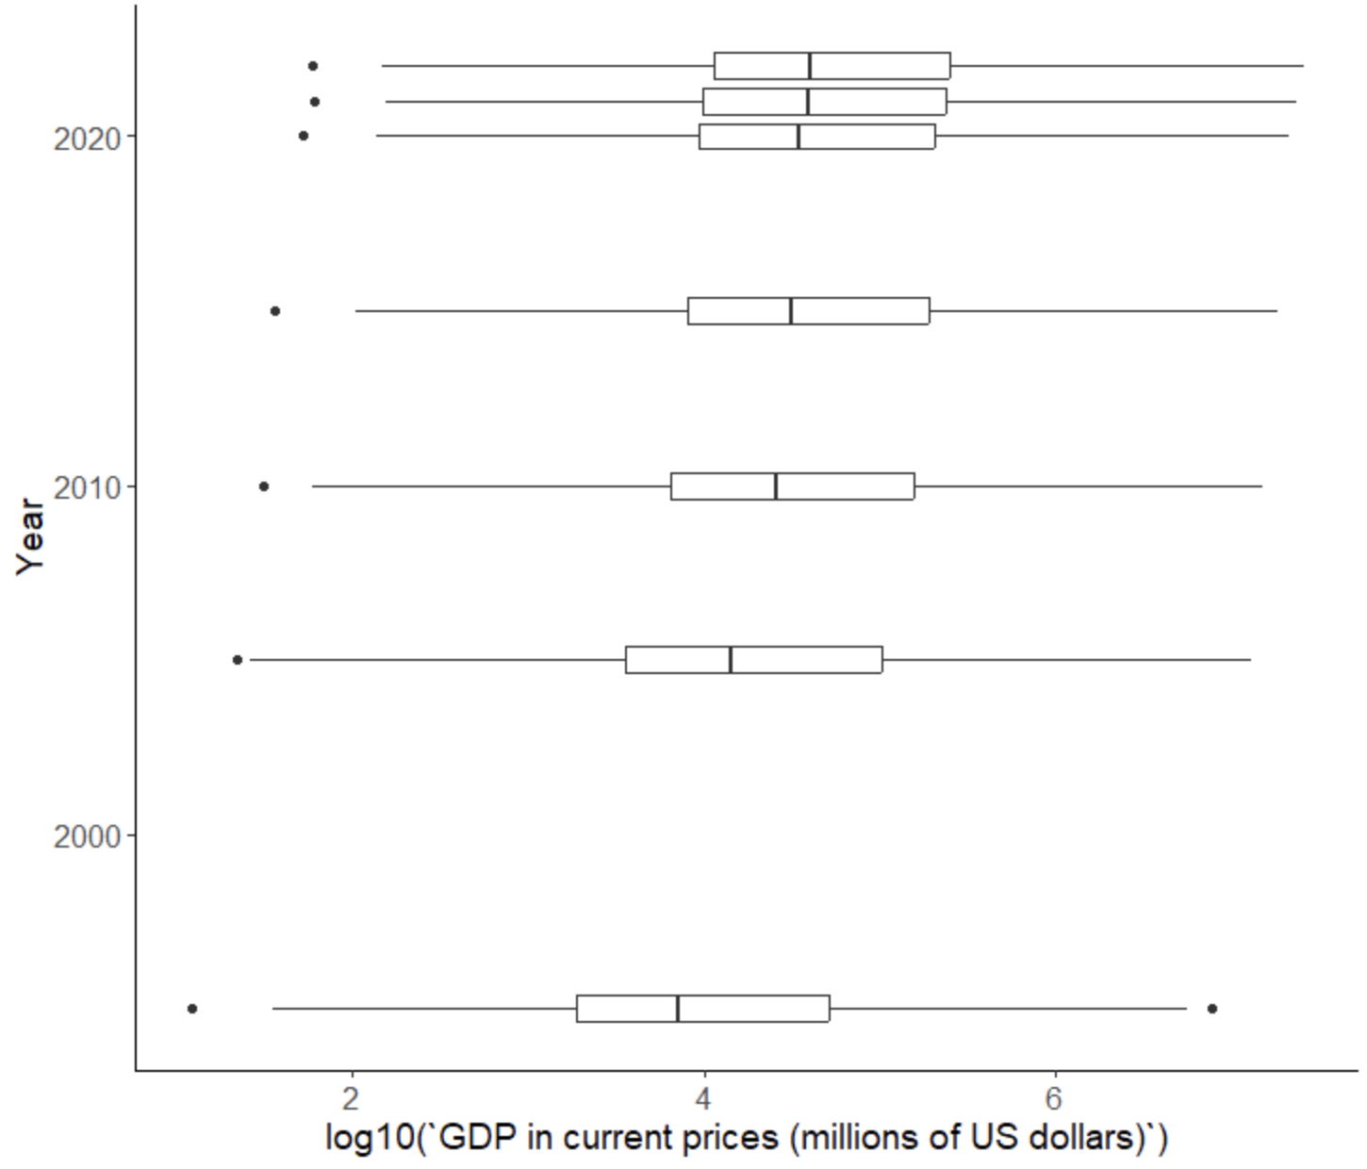

Visualization 4: GDP Boxplots Over Time (Static)

How to interpret:

Each horizontal box shows the distribution of log10(GDP, millions of USD) for a specific year, from 2000 to 2020. The boxes show the middle 50% of countries, and outliers are marked with dots.

Why it matters:

This lets us see if the distribution of wealth across countries is getting narrower or wider over time.

Example takeaway:

The middle boxes move to the right, showing that most countries’ GDPs are increasing, but the gap between the richest and poorest is still big.

Strength:

Easy to spot trends over time and see economic growth.

Weakness:

Log scale can be hard for some users to understand, and the outliers aren’t labeled.